**Department of Computer Engineering**



**Cairo University**

**Faculty of Engineering**

**ELC 3070 – Spring 2024**

**Communications 2**

**Project #2**

**Matched Filter**

**Submitted to**

Dr. Mohamed Khairy

Dr. Mohamed Nafea

Eng. Mohamed Khaled

**Submitted by**

**Team: 31**

|  |  |  |  |
| --- | --- | --- | --- |
| Name | ID | Sec. | B.N. |
| عبدالله ابراهيم السيد عبدالهادي | 9210602 | 2 | 48 |
| عمر احمد عبد العليم مرزوق | **9210704** | 3 | 7 |
| فتحى مصطفى فتحى عبدالحميد | **9210808** | 3 | 19 |
| محمود حمدى جابر عبد التواب | **9211083** | 4 | 10 |

Contents

**Role of each member** 3

**Requirement 1: Matched filters and correlators in noise-free environment** 3

**Part A: Matched and Unmatched filters Ouputs** 5

**Comment:** 5

**Part B: Correlator** 5

**Comment:** 6

**Requirement 2: Noise Analysis** 6

**Comment:** 6

**Requirement 3:** **ISI and raised cosine** 7

**At Point A: Transmitted signal** 8

**A.** **R = 0, delay = 2.** 8

**B.** **R = 0, delay =8.** 9

**C.** **R = 1, delay =2.** 9

**D.** **R = 1, delay =8.** 10

**Comment:** 10

**At Point B: Received signal** 11

**A.** **R = 0, delay =2.** 11

**B.** **R = 0, delay =8.** 11

**C.** **R = 1, delay =2.** 12

**D.** **R = 1, delay =8.** 12

**Comment:** 12

**Index:** 13

Figures

Figure 1 Pulse Shaping. 3

Figure 2 : UP Sampled Data. 4

Figure 3 Output of Convolution 4

Figure 4 : Matched and Unmatched Filter Output 5

Figure 5 : Output of the matched filter and correlator 5

Figure 6 : BER of matched filter and unmatched filter with theoretical BER using 10000 bits 6

Figure 7: BER of matched filter and unmatched filter with theoretical BER using 1,000,000 bits 7

Figure 8 : square root raised cosine 8

Figure 9: Transmitted signal Eye diagram at R=0 & Delay=2 8

Figure 10: Transmitted signal Eye diagram at R=0 & Delay=8 9

Figure 11: Transmitted signal Eye diagram at R=1 & Delay=2 9

Figure 12: Transmitted signal Eye diagram at R=1 & Delay=8 10

Figure 13: Received signal Eye diagram at R=0 & Delay=2 11

Figure 14: Received signal Eye diagram at R=0 & Delay=8 11

Figure 15: Received signal Eye diagram at R=1 & Delay=2 12

Figure 16: Received signal Eye diagram at R=1 & Delay=8 12

# **Role of each member**

|  |  |
| --- | --- |
| Members | Role |
| Abdallah Ibrahim | Requirement 2 (Noise Analysis ) |
| Omar Marzouk | Requirement 3 (ISI and Raised Cosine) |
| Fathy Mostafa | Requirment 1 (Matched Filters and Correlators) |
| Mahmoud Hamdy | Report Organization |
| All of the members | checking code reliability |

# **Requirement 1: Matched filters and correlators in noise-free environment**

To simulate a binary PAM signaling system, we start by generating 10 random binary bits. These bits are then converted into PAM symbols, where logic 1 becomes +1 and logic 0 becomes -1. The symbol duration is 1 second.To represent the pulse shaping function discreetly, we use 5 samples equally spaced, with a difference of 200 ms between each sample. This pulse shaping function is normalized to ensure that its energy is unity.

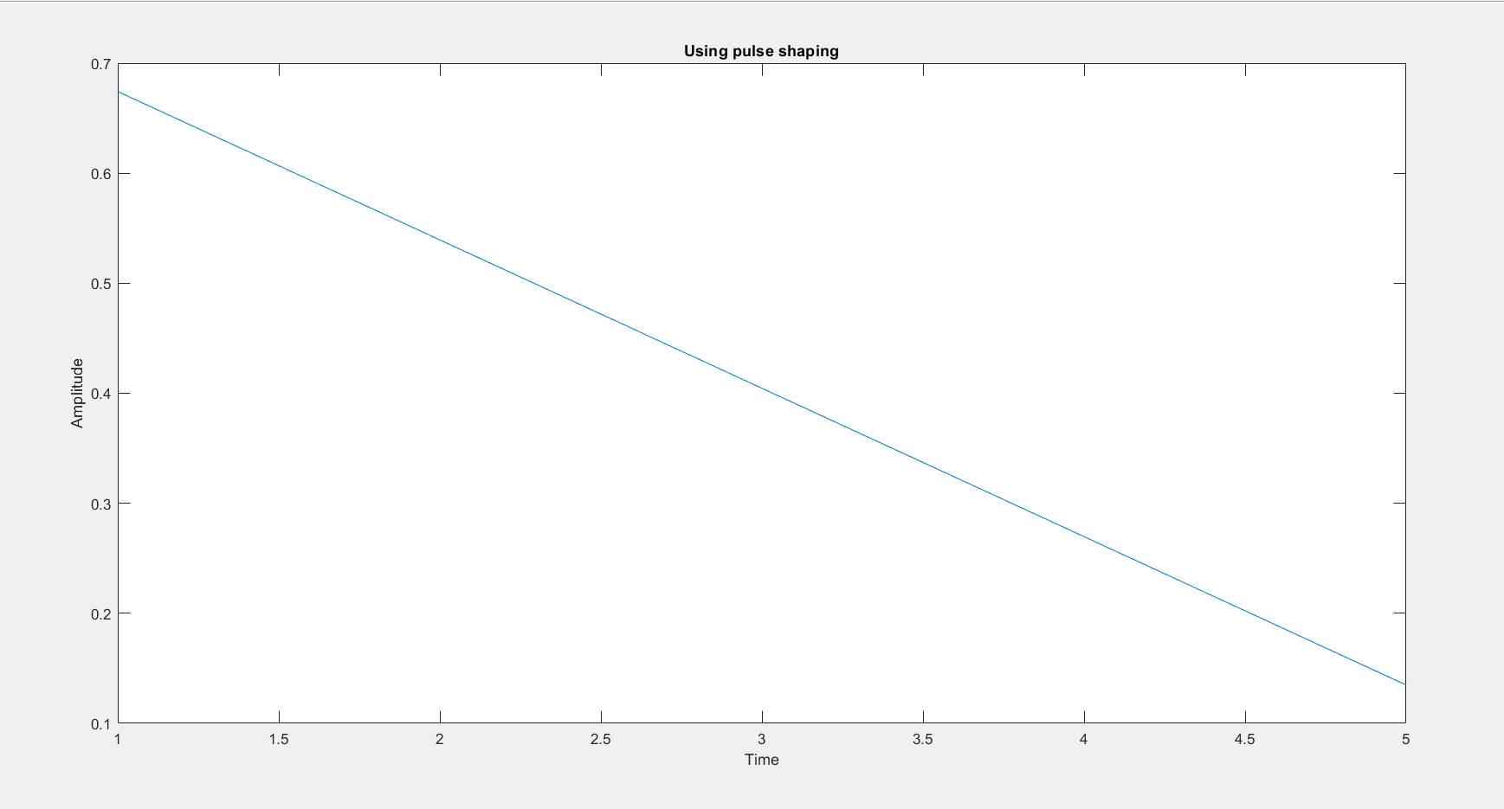

Figure Pulse Shaping.

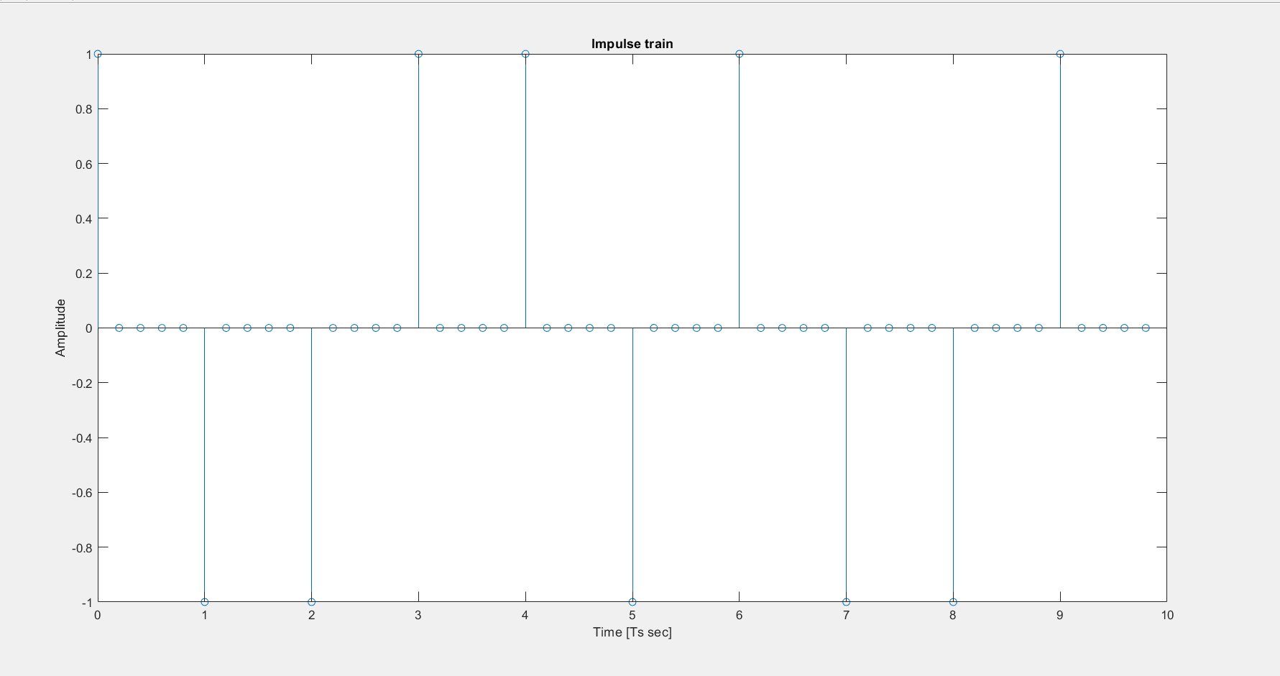

Figure : UP Sampled Data.

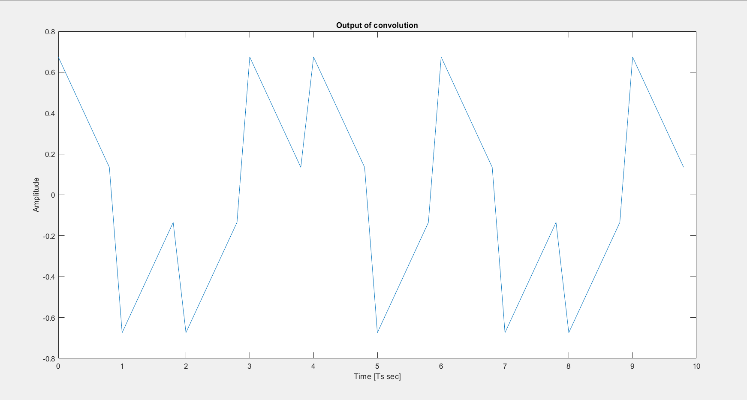

Figure Output of Convolution

## **Part A: Matched and Unmatched filters Ouputs**

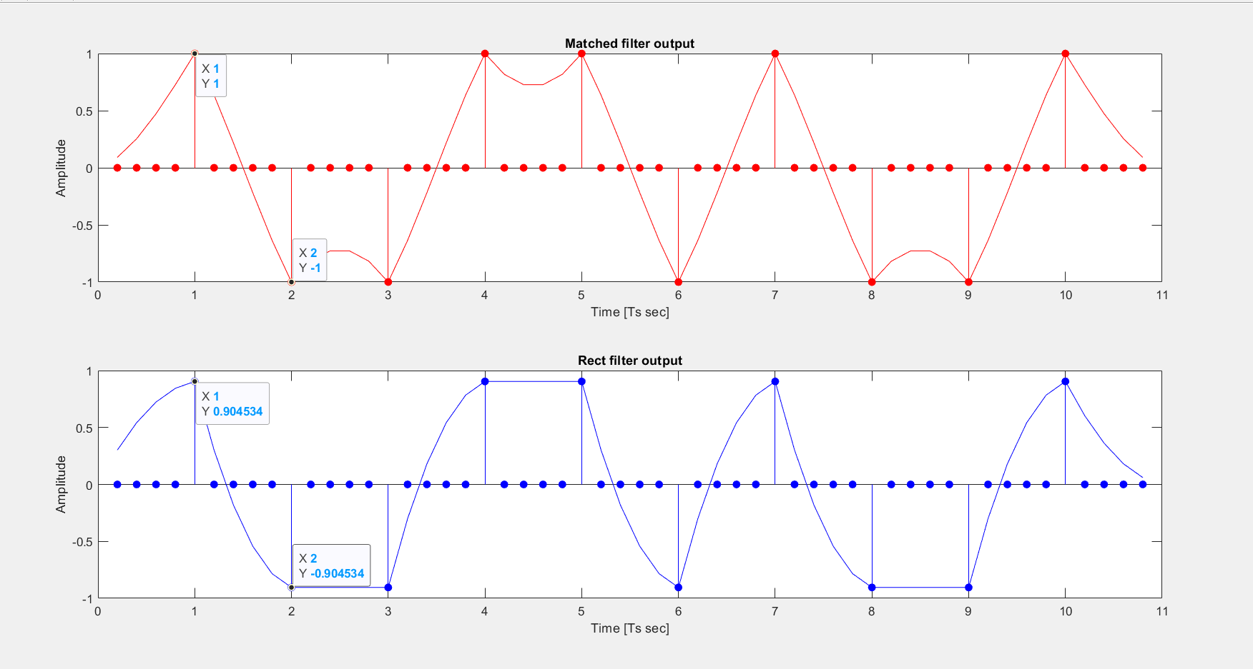

Figure 4 : Matched and Unmatched Filter Output

## **Comment:**

At the sampling instance, the amplitude of the signal precisely reaches ±1 after passing through the matched filter. Conversely, when passing through the rectangular filter, the signal's level is slightly lower at 0.904, which is less than 1. As the amplitudes of the samples increase, using matched filter minimizing errors and maximizes the signal-to-noise ratio (SNR).

# **Part B: Correlator**

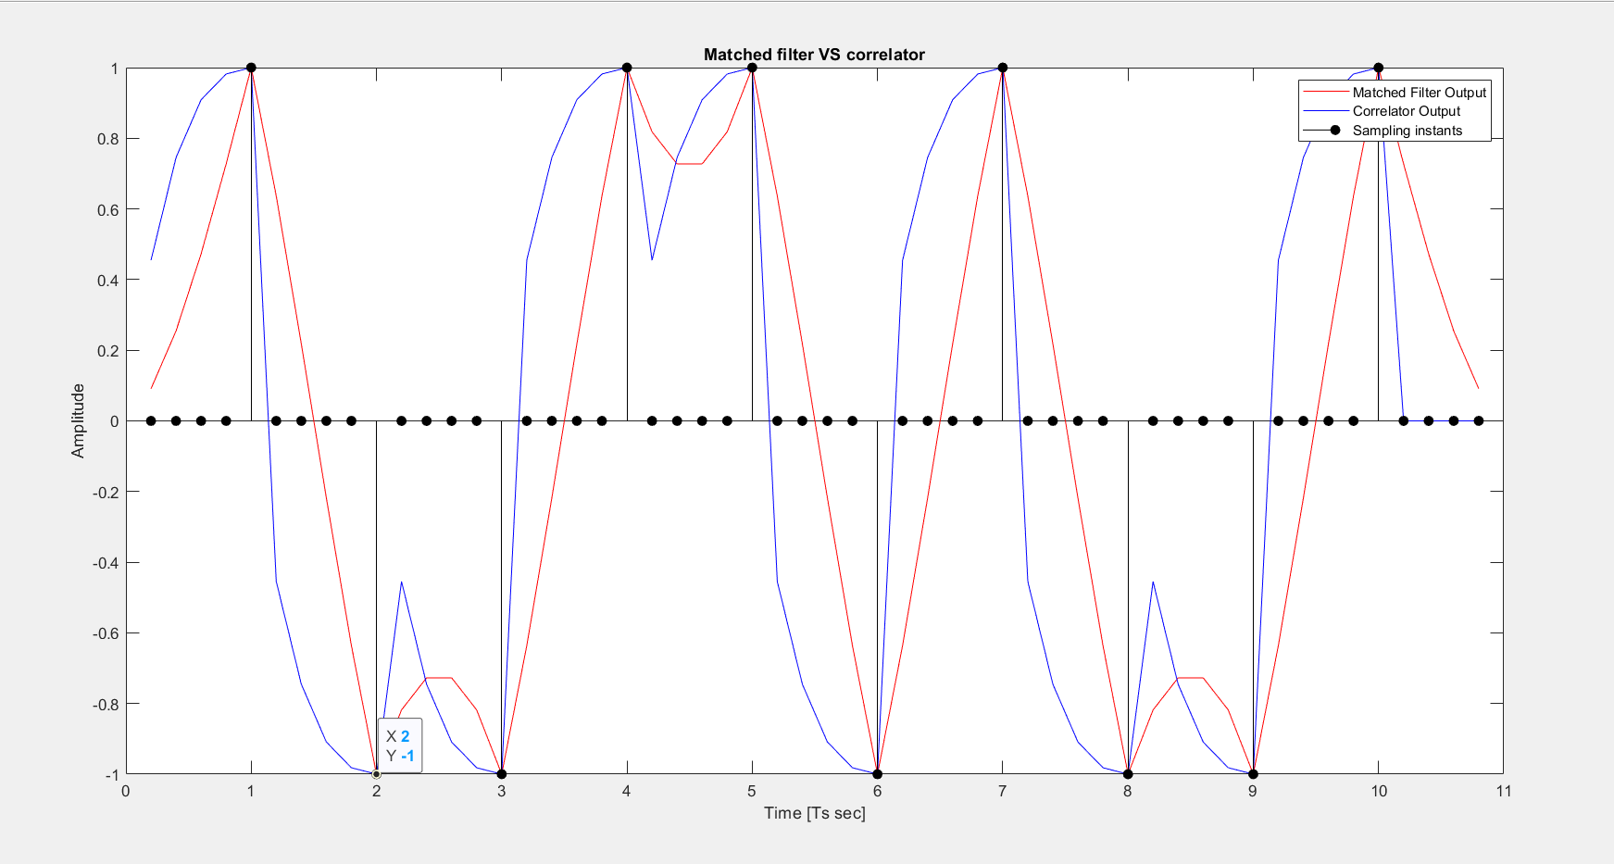

Figure : Output of the matched filter and correlator

## **Comment:**

The output of the correlator equals convolution between the received signal and the pulse shaping function, which is identical to the output of the matched filter at those instances. Since we are sampling at time equal TS, this equivalence maximizes the signal-to-noise ratio (SNR) at sampling instances.

# **Requirement 2: Noise Analysis**

The process involves expanding the initial bit sequence of 10,000 bits, generating Gaussian noise with zero mean and unity variance matching the size of the sequence. This noise is then scaled to achieve a variance of N0/2. It's added to the transmitted sequence, and the resulting signal is filtered using a matched filter or a rect filter and sampled. The probability of error is calculated based on a 10,000-sample array. Additionally, N0 is adjusted iteratively to vary Eb/N0 from -2 dB to 5 dB in 1 dB steps, with the BER calculated at each step

Figure : BER of matched filter and unmatched filter with theoretical BER using 10000 bits

## **Comment:**

Matched filters are designed to maximize the peak Signal-to-Noise Ratio (SNR), making them more efficient. So even with equivalent Energy to Noise Spectral Ratio (Eb/No), the Bit Error Rate (BER) tends to be lower with a matched filter than with an unmatched filter. Also, the matched filter BER is nearly equal to the theoretical BER

So to produce more accurate results, we used a larger number of bits (1,000,000)

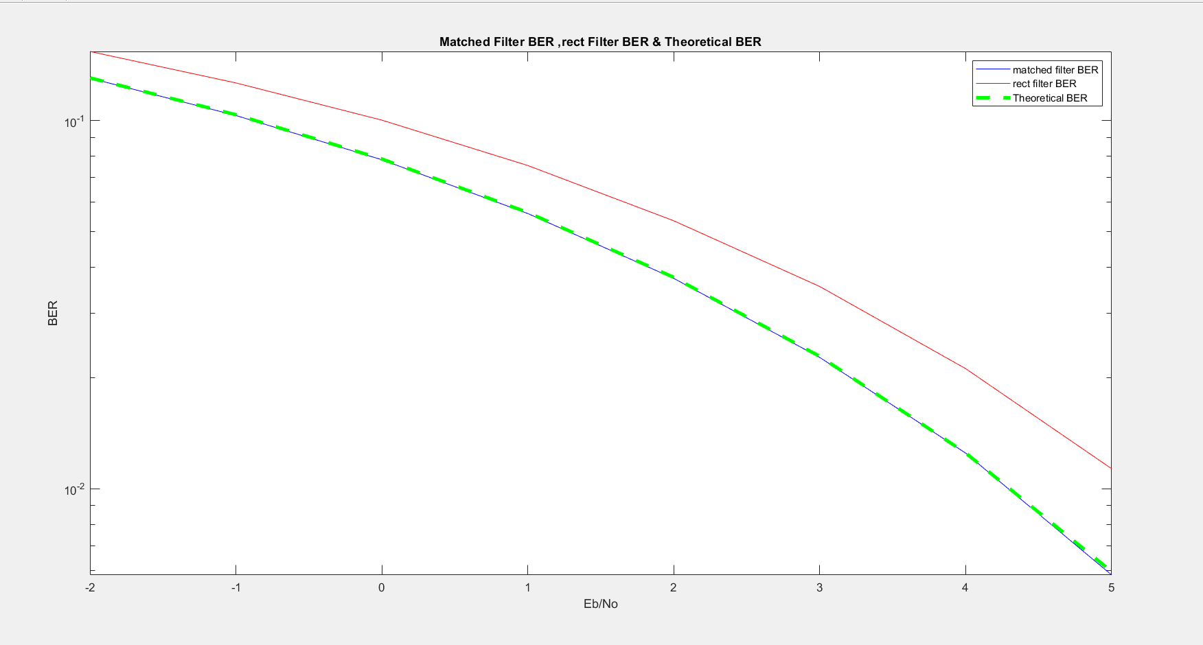

Figure 7: BER of matched filter and unmatched filter with theoretical BER using 1,000,000 bits

As the number of bits approaches infinity, the BER of the matched filter approaches the theoretical result.

# **Requirement 3:** **ISI and** **raised cosine**

To illustrate the impact of Inter-Symbol Interference (ISI), we employ a noise-free system characterized by square root raised cosine filters for both transmission and reception. The raised cosine filter is chosen due to its ability to meet the Nyquist criterion, ensuring efficient data transmission by minimizing ISI. Although the ideal square root raised cosine filter is theoretically optimal, its infinite impulse response renders it impractical for real-world applications. Thus, we utilize a parameterized approach to define the practical length of the filter, represented by the delay parameter fig [9], and control the filter's bandwidth using the Rolloff factor, denoted as R. By employing square root raised cosine (SRRC) filtering at both ends, we aim to approximate the response of a raised cosine filter. This ensures that the resultant system exhibits the desired characteristics, facilitating a clearer understanding of ISI through the visualization of eye patterns, which graphically represent the received signal's characteristics over time.

Figure : square root raised cosine

## **At Point A: Transmitted signal**

### **R = 0, delay = 2.**

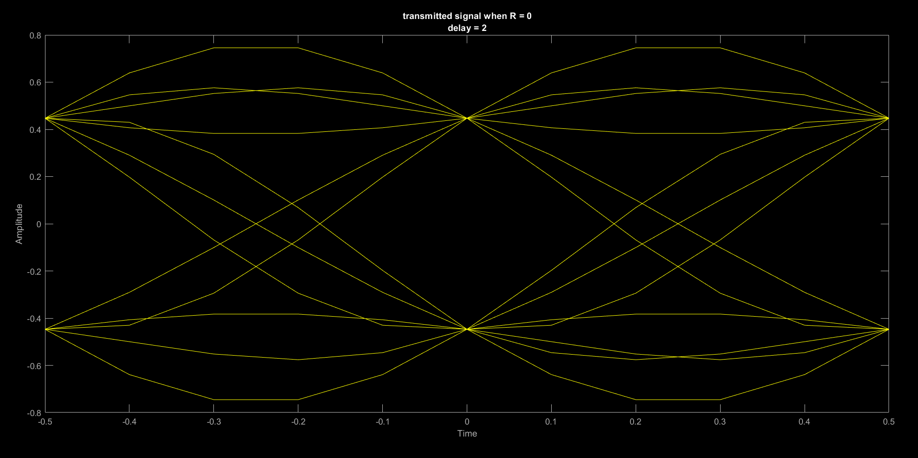

Figure : Transmitted signal Eye diagram at R=0 & Delay=2

### **R = 0, delay =8.**

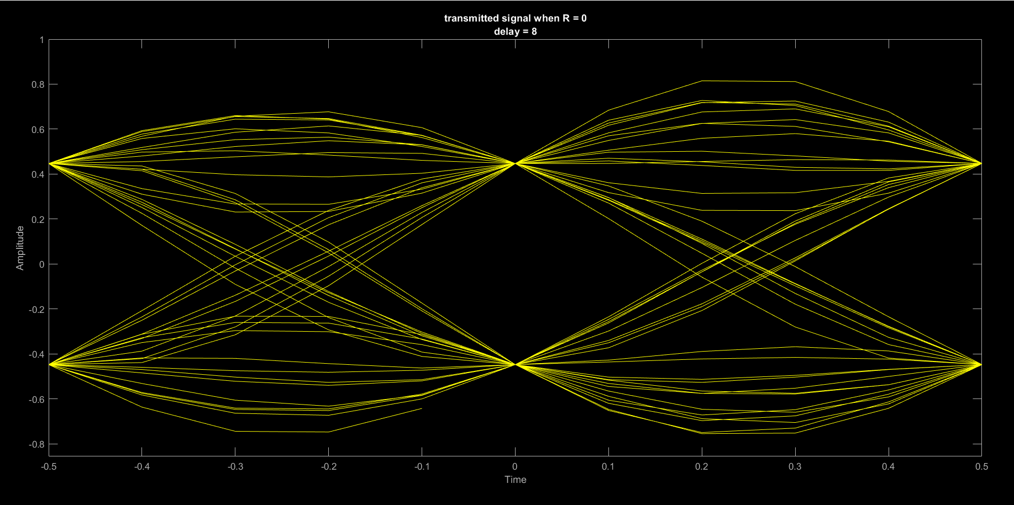

Figure 10: Transmitted signal Eye diagram at R=0 & Delay=8

### **R = 1, delay =2.**

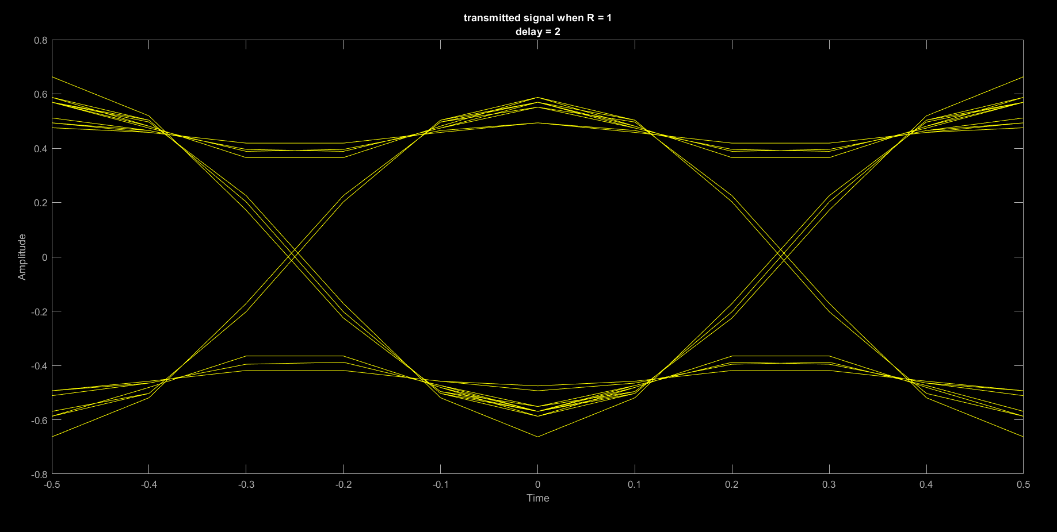

Figure 11: Transmitted signal Eye diagram at R=1 & Delay=2

### **R = 1, delay =8.**

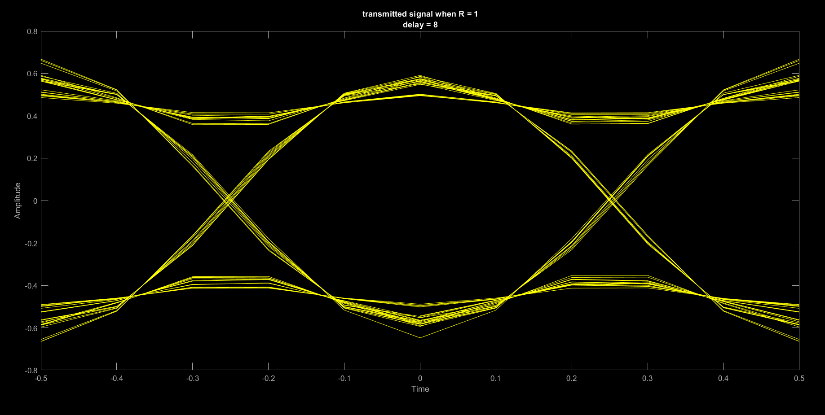

Figure 12: Transmitted signal Eye diagram at R=1 & Delay=8

## **Comment:**

The Optimal sampling instant corresponds to the center of the eye-opening in an eye diagram. A wider eye opening indicates a greater tolerance for timing errors, whereas a narrower opening suggests a higher risk of sampling errors. Optimal sampling instant placement maximizes signal integrity and minimizes inter-symbol interference. A higher roll-off factor typically results in a wider eye-opening but increasing bandwidth.

* For R = 0:

square root raised cosine filter is an infinite impulse response (Sinc function for R=0). Thus, we utilize a parameterized approach to define the practical length of the filter by the delay parameter which decides the number of peaks taken as in Fig [8]. In Fig [9][10] we can observe that There is no noticeable change in the eye pattern as after the transmitter the signal is exposed to only one SRRC filter. The effect of delay appears clearly after the receiver (raised cosine effect) where a clear eye pattern appears with delay =8 as in Fig [13][14]. This happens because Sinc's pulse doesn’t die quickly and needs more time to ignore the other pecks.

* For R = 1:

the bandwidth is increased to allow the pulse to die quickly which improves ISI and isn’t affected by the delay as side peaks in impulse response have ignored amplitudes compared to the main peak. These results appear clearly in figures [11][12] after the transmitter and figures [16][17] after the receiver.

## **At Point B: Received signal**

### **R = 0, delay =2.**

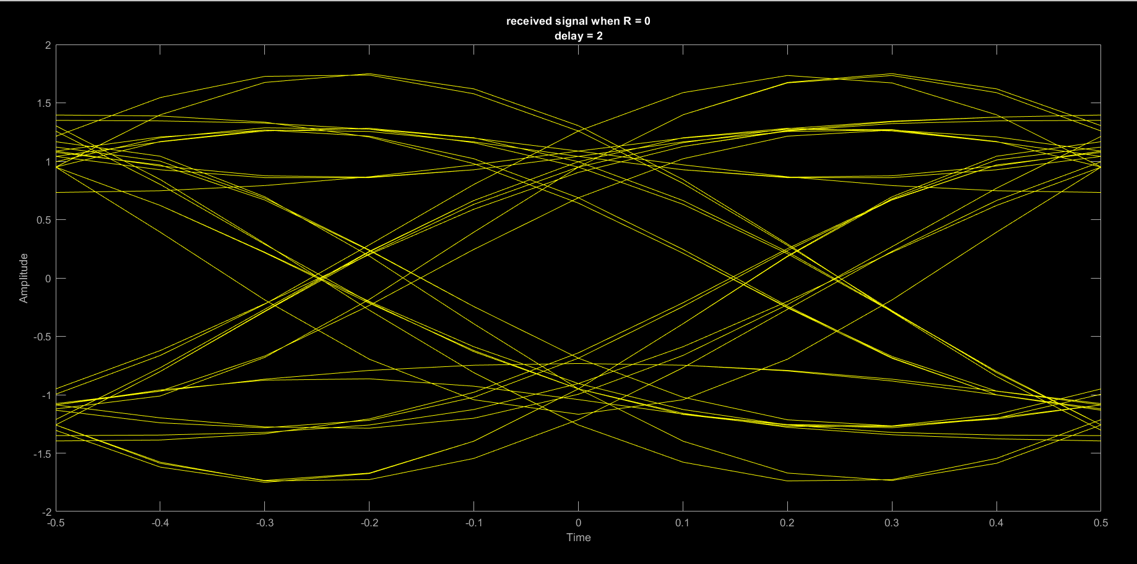

Figure 13: Received signal Eye diagram at R=0 & Delay=2

### **R = 0, delay =8.**

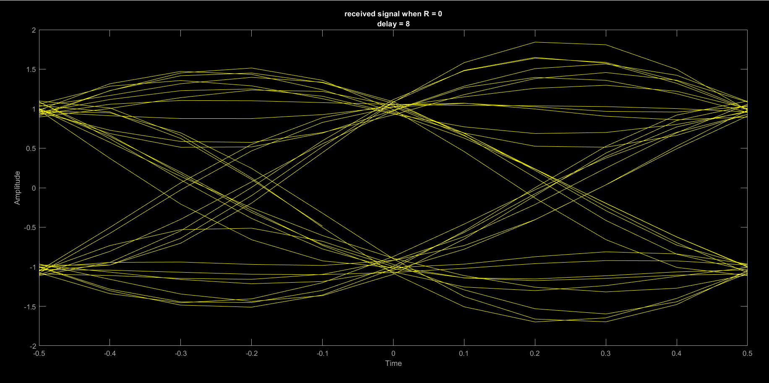

Figure 14: Received signal Eye diagram at R=0 & Delay=8

### **R = 1, delay =2.**

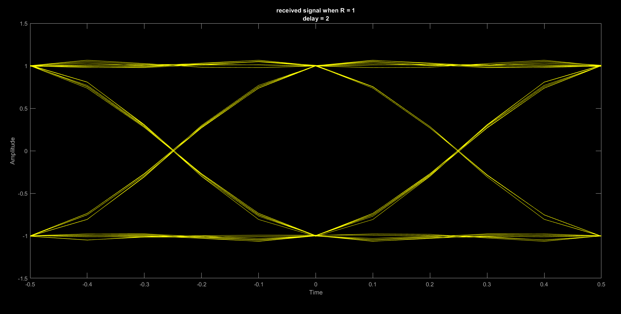

Figure 15: Received signal Eye diagram at R=1 & Delay=2

### **R = 1, delay =8.**

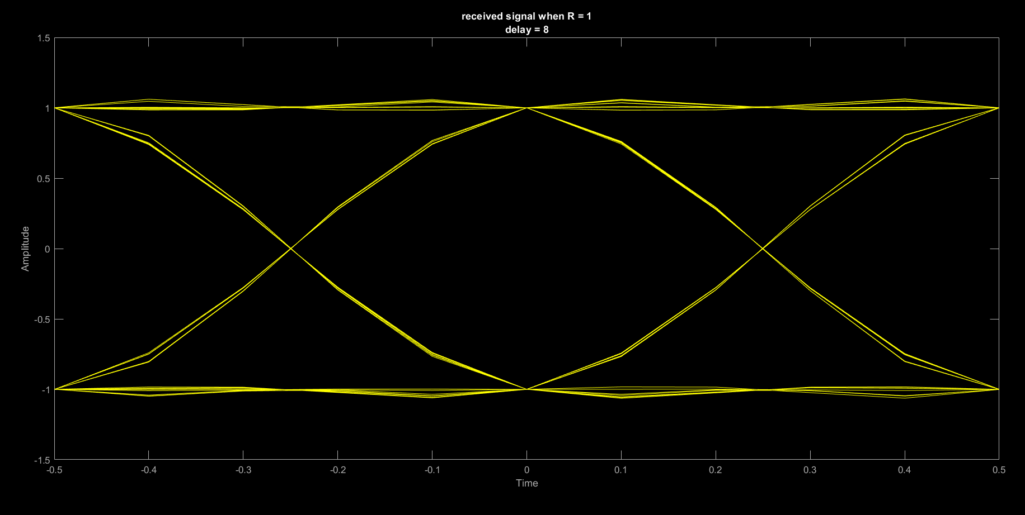

Figure 16: Received signal Eye diagram at R=1 & Delay=8

## **Comment:**

The received signal might experience distortion or noise, which can further affect the eye-opening. As it is considered the system is noise-free, the eye diagram won’t affected by these factors. Note that we utilize an SRRC pulse for both transmission and reception to ensure that the final result is a raised cosine pulse. The comment on the figures for this section has been clarified in the previous comment section.

# **Index:**

%%%%%%%%%%Matched Filters, Correlators, ISI, and raised cosine%%%%%%%%%%%%%

close all;

clear;

clc;

%%part 1 Matched filters and correlators in noise free environment%%

A=1; %voltage level

TS=1; %bit duartion

sampling_time=0.2; % we will take 5 samples for each bit

num_bits=10;

num_sample=num_bits*(TS/sampling_time);

data =randi([0,1],1,num_bits); %generate bits

data_mapping=2*data-1; %mapping data to-1,1

data_upsampling=upsample(data_mapping,(TS/sampling_time)); %represnting every bit using 5 samples

%and the rest be zeros

p=[5 4 3 2 1]/sqrt(55); %pulse shaping with unit energy

y=conv(data_upsampling,p); % y equal convolution of data_upsampling and the pulse shaping signal

y=y(1:num_sample); %convolution change size of data streamed

t = 0 : sampling_time : (num_sample - 1)*sampling_time; %start from zero until reach all samples

%plot the using pulse shaping

figure ;

plot(p);

title("Using pulse shaping");

xlabel("Time");

ylabel("Amplitude");

figure;

stem(t,data_upsampling);

title("Impulse train");

xlabel("Time [Ts sec]");

ylabel("Amplitude");

figure ;

plot(t,y);

title("Output of convolution");

xlabel("Time [Ts sec]");

ylabel("Amplitude");

%%design of matched filter

matched_filter=fliplr(p); % Matched filter (flipped pulse)

filter_2=ones(1,(TS/sampling_time))/sqrt(TS/sampling_time); %rect filter normalized

matched_filter_output=conv(matched_filter,y);

filter_2_output=conv(filter_2,y);

t_conv_adjust=sampling_time : sampling_time : (size(matched_filter_output,2))*sampling_time;

matched_filter_output_sampled=zeros(size(matched_filter_output));

filter_2_output_sampled=zeros(size(matched_filter_output));

for i=1:5:num_sample

matched_filter_output_sampled(i+4)=matched_filter_output(i+4);

filter_2_output_sampled(i+4)= filter_2_output(i+4);

end

figure;

subplot(2,1,1);

plot(t_conv_adjust,matched_filter_output,'r');

hold on

stem(t_conv_adjust,matched_filter_output_sampled,'r','filled')

title("Matched filter output");

xlabel("Time [Ts sec]");

ylabel("Amplitude");

axis ([0 11 -1 1]);

subplot(2,1,2);

plot(t_conv_adjust,filter_2_output,'b');

hold on

stem(t_conv_adjust,filter_2_output_sampled,'b','filled')

title("Rect filter output");

xlabel("Time [Ts sec]");

ylabel("Amplitude");

axis ([0 11 -1 1]);

%%correlator%%

correlator_output = zeros(size(matched_filter_output));

%repeat the pulse shape function by number of bits

pulse_shaping_correlator = repmat(p, 1, num_bits); %repeat pulse shaping the number of bits

sum_corr = 0; %initialization of integrator result

for i = 1 : num_sample

if mod((i-1), 5) == 0 %(i-1)%5

sum_corr = 0;

end

correlator_output(i) = sum_corr + (pulse_shaping_correlator(i) * y(i));

sum_corr = correlator_output(i);

end

correlator_output_sampled=zeros(size(matched_filter_output));

for i=1:5:num_sample

correlator_output_sampled(i+4)=correlator_output(i+4);

end

figure

subplot(2,1,1)

plot(t_conv_adjust,matched_filter_output,'r');

hold on ;

stem(t_conv_adjust,matched_filter_output_sampled,'r','filled');

title("Matched filter Output");

xlabel("Time [Ts sec]");

ylabel("Amplitude");

axis ([0 11 -1 1]);

subplot(2,1,2)

plot(t_conv_adjust,correlator_output,'b');

hold on ;

stem(t_conv_adjust,matched_filter_output_sampled,'b','filled');

title("Correlator Output");

xlabel("Time [Ts sec]");

ylabel("Amplitude");

axis ([0 11 -1 1]);

figure

plot(t_conv_adjust,matched_filter_output,'r');

hold on ;

plot(t_conv_adjust,correlator_output,'b');

hold on;

stem(t_conv_adjust,matched_filter_output_sampled,'k','filled');

title("Matched filter VS correlator");

xlabel("Time [Ts sec]");

ylabel("Amplitude");

legend('Matched Filter Output', 'Correlator Output','Sampling instants');

axis ([0 11 -1 1]);

%%%

noise_num_bits=10000;

noise_data = randi([0,1],1,noise_num_bits); %generating 10000 random bits

noise_data_mapping = (2*noise_data - 1); %converting 0 to -1 and 1 to +1

noise_data_upsampling = upsample(noise_data_mapping,5); %sapmle every 200ms

y_noise= conv(noise_data_upsampling,p); %output of the transmitter

y_noise(:,50001:50004) = []; %taking only nonzero values

noise = randn(1,size(y_noise,2));

No=1;

Eb=sum(p .^2);

x=1;

Rect_Filter_BER=zeros(1,8);

Matched_Filter_BER=zeros(1,8);

Theoretical_BER=zeros(1,8);

for j=-2:5

No=Eb/(10^(j/10));

noise_scaled = noise.*sqrt(No/2);

v_noise = y_noise+noise_scaled; %adding noise to signal

%Matched and normalized filters---------------------------------

matched_filter_noise = fliplr(p);

matched_filter_noise_out = conv(v_noise , matched_filter_noise);

rect_filter_noise = [5 5 5 5 5]/sqrt(125);

rect_filter_noise_out = conv(v_noise,rect_filter_noise);

for i=1:noise_num_bits

matched_filter_noise_out_Sampled(i) = matched_filter_noise_out(i*5); %sampling every Ts=5*200ms

rect_filter_noise_out_Sampled(i) = rect_filter_noise_out(i*5);

end

%Comparing with threshold for matched filter

for i = 1:length(matched_filter_noise_out_Sampled)

if matched_filter_noise_out_Sampled(i)<0

matched_filter_noise_out_Sampled(i) = -1;

elseif matched_filter_noise_out_Sampled(i)>0

matched_filter_noise_out_Sampled(i) = 1;

end

end

%Comparing with threshold for matched filter

for i = 1:length(rect_filter_noise_out_Sampled)

if rect_filter_noise_out_Sampled(i)<0

rect_filter_noise_out_Sampled(i) = -1;

elseif rect_filter_noise_out_Sampled(i)>0

rect_filter_noise_out_Sampled(i) = 1;

end

end

%Getting BER------------------------------------------------------

%ber

ber_matched_fitler_sum=0;

ber_RECT_sum=0;

for i=1:length(matched_filter_noise_out_Sampled)

if(matched_filter_noise_out_Sampled(i)~= noise_data_mapping(i))

ber_matched_fitler_sum=ber_matched_fitler_sum+1;

end

end

for i=1:length(rect_filter_noise_out_Sampled)

if(rect_filter_noise_out_Sampled(i)~= noise_data_mapping(i))

ber_RECT_sum=ber_RECT_sum+1;

end

end

Theoretical_BER(x)=0.5*erfc(sqrt(Eb/No));%Getting theoritical BER

Matched_Filter_BER(x)=ber_matched_fitler_sum/noise_num_bits;

Rect_Filter_BER(x)=ber_RECT_sum/noise_num_bits;

x=x+1;

end

%Plots------------------------------------------------------------

figure;

semilogy(-2:5,Matched_Filter_BER,'b');

hold on

semilogy(-2:5,Rect_Filter_BER,'r');

hold on

semilogy(-2:5, Theoretical_BER,'g');

xlabel('Eb/No');

ylabel('BER');

legend('matched filter BER','rect filter BER','Theoretical BER');

title('Matched Filter BER ,rect Filter BER & Theoretical BER');

%%ISI %%%%%%

ISI_num_bits=100;

ISI_data=randi([0,1],1,ISI_num_bits);

ISI_data_mapping=(2*ISI_data - 1);

ISI_data_upsampling=upsample(ISI_data_mapping,5);

R=[0 0 1 1]; %different roll of factor

delay=[2 8 2 8]; %different delays

for i=1:4

square_root_raised_cosine=rcosine(TS,TS/sampling_time,'sqrt', R(i), delay(i));

figure ('Name', 'SRRC');

plot( square_root_raised_cosine);

title(sprintf('SRRC of R = %d delay = %d', R(i), delay(i)));

TX=conv(ISI_data_upsampling,square_root_raised_cosine,'valid');

RX=conv(TX,square_root_raised_cosine,'valid');

eyediagram(TX,2*TS/sampling_time);

title(sprintf('transmitted signal when R = %s\ndelay = %s', string(R(i)), string(delay(i))));

eyediagram(RX,2*TS/sampling_time);

title(sprintf('received signal when R = %s\ndelay = %s', string(R(i)), string(delay(i))));

end